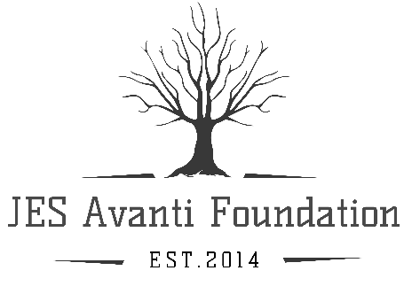

Thank you for your interest in the JES Avanti Foundation’s 2020 Watershed Stewardship Adventure Day Camp!
This tuition free camp is open to students who are interested in learning about our Chesapeake Bay, its aquatic environment, and ways we can conserve it.
In order to ensure a quality program, there is limited space and students will be selected through an application process. The foundation is seeking applicants who will have an ongoing interest in an environmental field for their future endeavors.
Our goal is to facilitate awareness and exploration of our amazing watershed and encourage lifelong stewardship of our natural world.
There will be several full day field trips to various environmental and research institutions. We will also visit naturalists, scientists, and researchers where our students will assist in diverse hands on activities. Our day camp is constantly on the move and involves many outdoor activities. We will be exploring our natural surroundings through hikes, boat rides, kayaking, and numerous scientific opportunities.
The camp headquarters is located at 21801 Whites Neck Road, Bushwood, MD. Our camp operates from 8:00am to 4:30pm. However, times may be adjusted as needed for field trip days.
For more information on the JES Avanti Foundation and to view our adventures from the 2019 Watershed Stewards Summer Day Camp, please visit our website at JESAvantiFoundation.org.
2020 Camp Dates:
June 22-26th Elementary School-Grades 3-5
July 6-10th To Be Determined- Grade Range not confirmed
Please e-mail any questions to JESAvantiFoundation@gmail.com.
APPLICATION
Attached are the application requirements. Please return all requested information by February 29, 2020 by mail to:
JES Avanti Foundation, Inc. Summer Camp
7350 Knolltop Place,
Hughesville, MD 20637.

